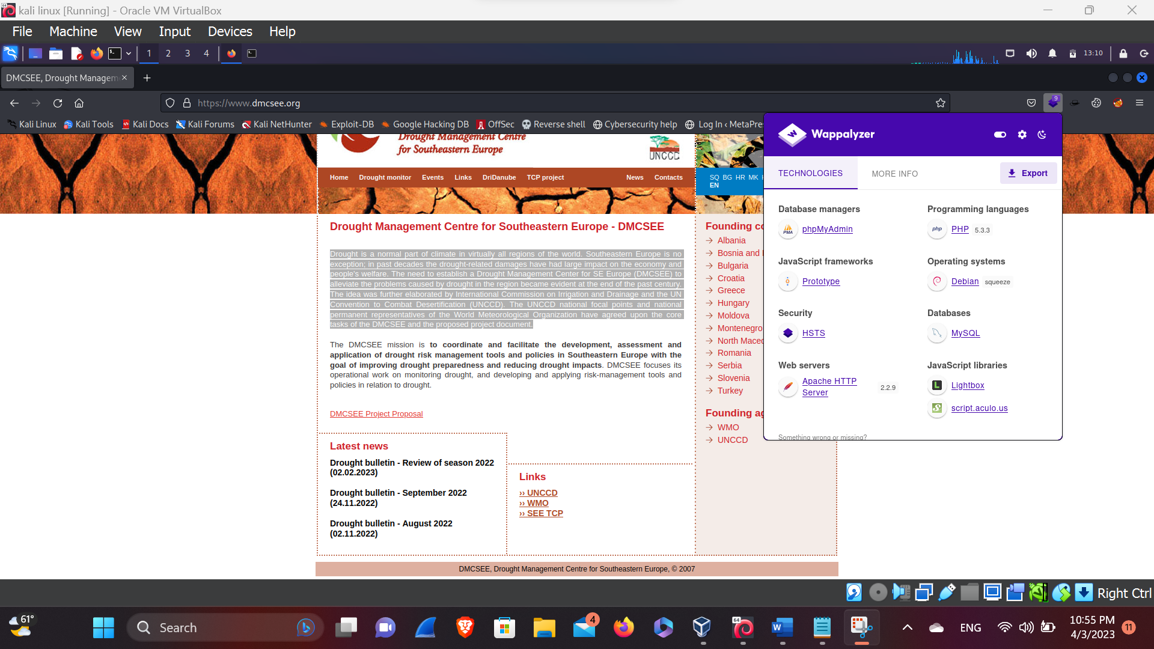**Drought Management Centre for Southeastern Europe - DMCSEE**

Drought is a normal part of climate in virtually all regions of the world. Southeastern Europe is no exception; in past decades the drought-related damages have had large impact on the economy and people's welfare. The need to establish a Drought Management Center for SE Europe (DMCSEE) to alleviate the problems caused by drought in the region became evident at the end of the past century. The idea was further elaborated by International Commission on Irrigation and Drainage and the UN Convention to Combat Desertification (UNCCD). The UNCCD national focal points and national permanent representatives of the World Meteorological Organization have agreed upon the core tasks of the DMCSEE and the proposed project document.

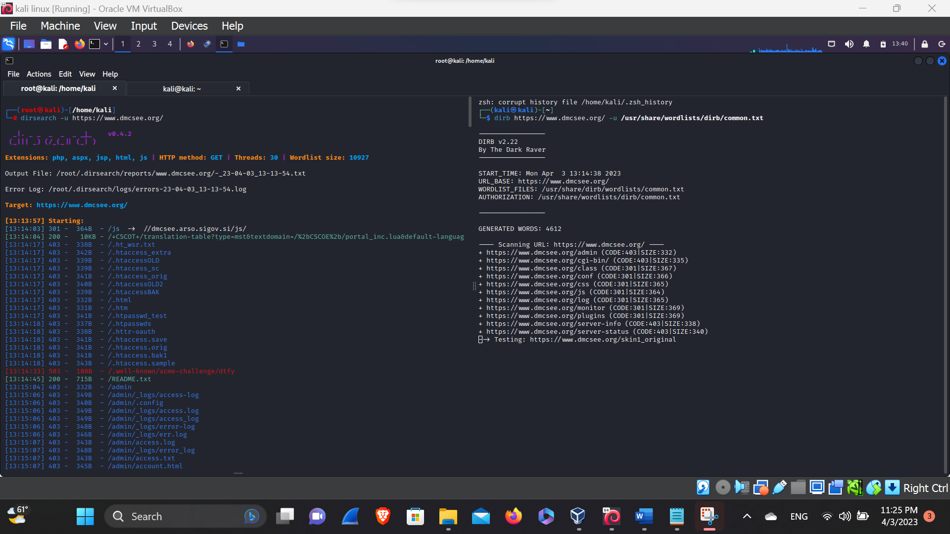**Directory Listing**

Here, in this above picture we’ve done the directory listing from different tools like dirsearch, dirb and we have got some of the directory let’s try and let’s exploit the web App if the site is not secure.

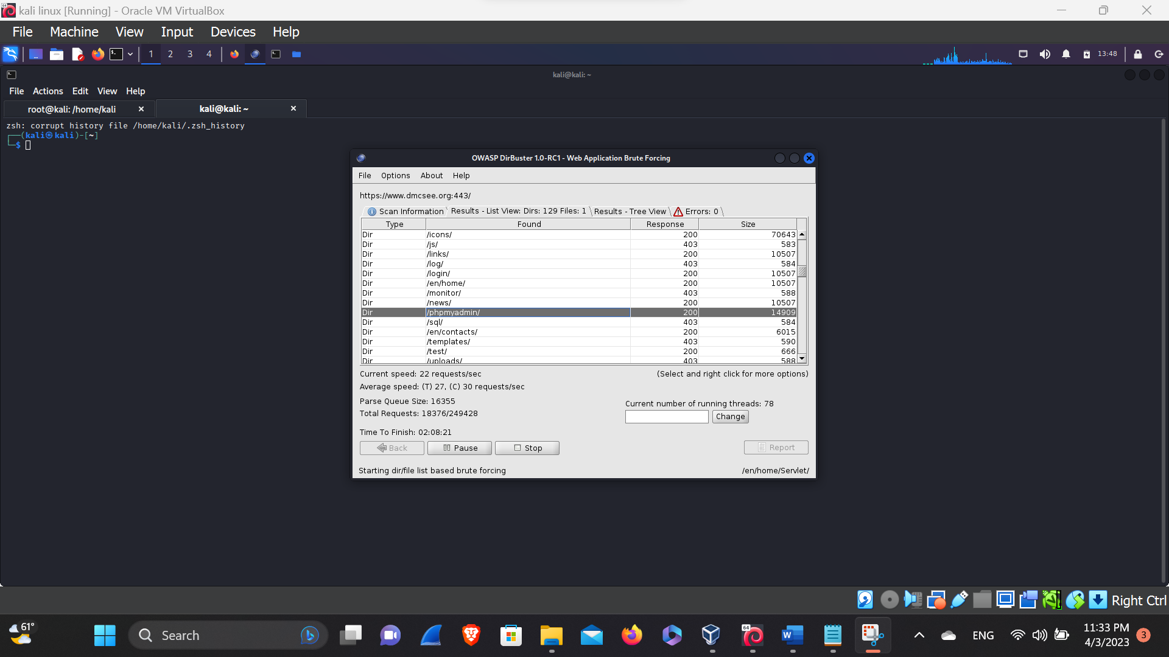**Dirbuster**

Here, in this above picture we’ve found some juicy information, that can and attacker take advantage of it. So, let’s try phpMyAdmin and let’s try to exploit it.

**PhpMyAdmin**

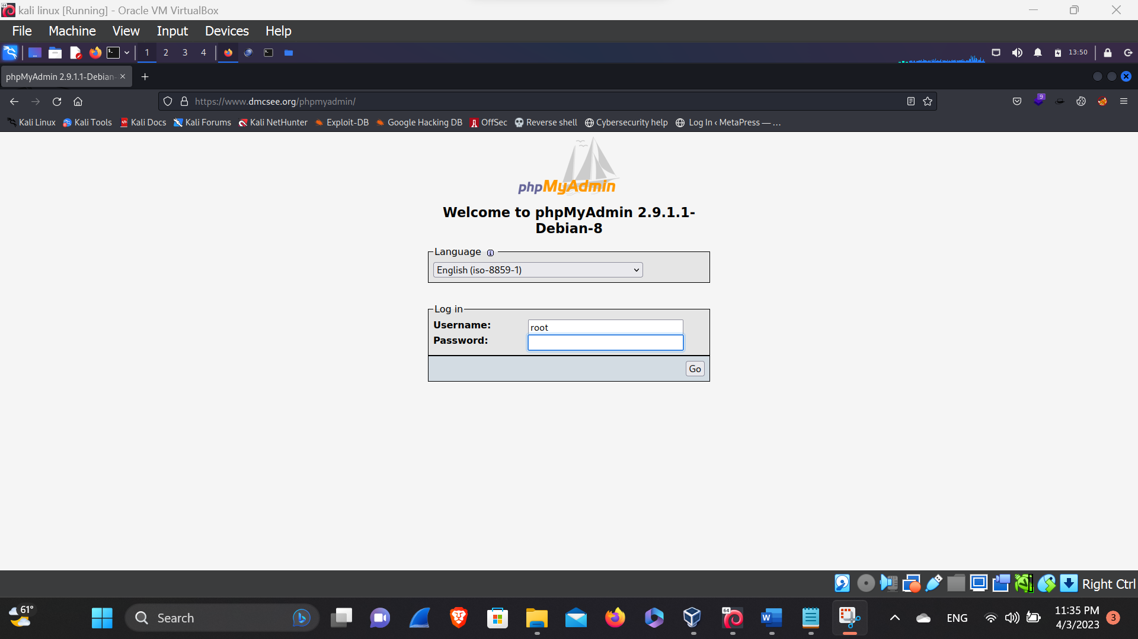

Here, in this above picture, we have found the admin panel login so, let’s try to exploit it from the default username and password.

After attempting all the possible bug impact we’ve not found anything that we can impact the website. So, let’s try another way…

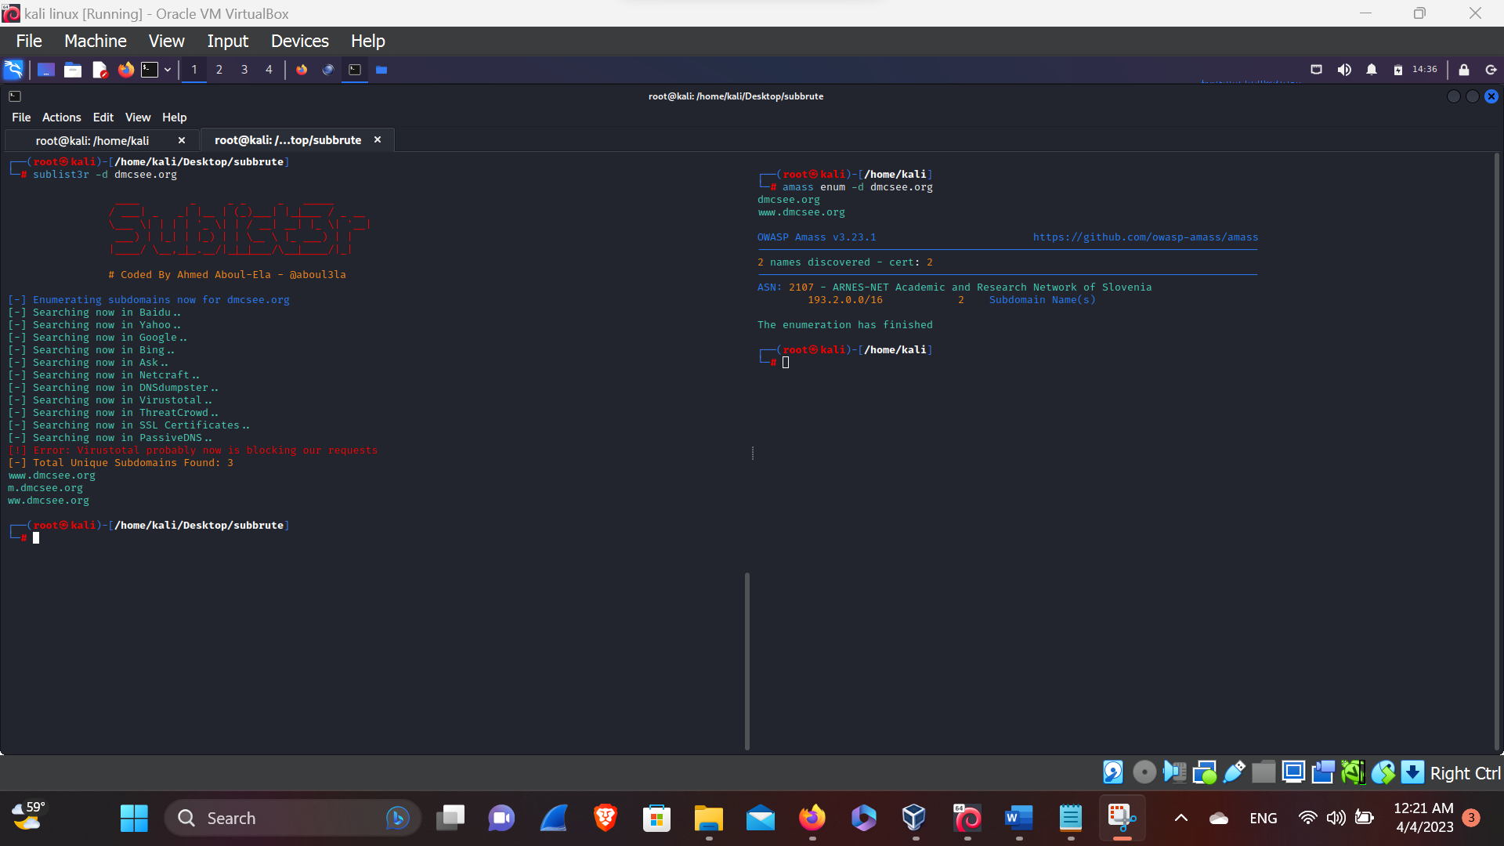**Sub-domain Enumeration**

Here, in this above picture we’ve found some subdomain from the tools like sublist3r, amass so, let’s visit the subdomain and let’s do information gathering.

After visiting the subdomain we’ve not found the page it say’s that 503. Maybe it is getting blocked by the firewall.